Design Documentation of Assignment 2
- Design
- Thoughts and overall approach
- Presentation of the figures. Positions of each object, including snakes, monsters and foods, have been decided by tuples. At the start of the game, the positions of the foods are randomly decided.
- Changing the direction of the snake. The list aim determines the sides the direction of the snakes motion. The function change is to change the element of aim. The four direction keys are attached with change function with different arguments.
- Judge the relative position of the snake and the monster. Compare the coordinates of the snake 's head and body with the monster. If the coordinates of the monster is Twenty units close to any part of the body, then the snake and the monster are contracted. The number of contract will plus one. If the position of snake's head and monster is twenty units closer than they are contacted and game losts.
- Just the game status (win or lose). If the snake's head is contacted with the monster, the game lost and ontimer stops. If the list of food is empty, which means all the foods are consumed before the snake is caught by the monster, then the game succeed.
- Data Types
turtle()
deepcopy: Constructs a new compound object and then, recursively, inserts copies into it of the objects found in the original.
Snake: a list consists of bivariate tuples.
Monster: a bivariate tuple.
Head: the last element of the snake. It is a tuple.
Time: returns a timestamp in the form of float.
Finished: A boolean. It is ‘True’ if the game is won or lost. Otherwise it is ‘False’.
State_running. A boolean to decide whether the snake and the monster should continue their motion. If the spacebar is pressed, the boolean value of state_running can be switched.
- Motion logics
- For snake: The list of snake appends a tuple which represents the coordinate of the snake's head in the meantime the first element of the list which represents the tail of the snake is popped. Every time the function move_monster is called, the body of the snake will be drawn according to the list. When the snake is extending its body, the ontimer of the function of moving snake is changed to 250 miniseconds.
- For monster: The position of the monster is represented by a tuple every time when the function is called. The X and y coordinates of the monster will be added a number, So as to make the most are closer to the snake's head.
- Body Extend logic
In normal status, the tail is popped when the head is upended, but when the snake is extending its body. The tail will not be popped unless it has finished the required number of times.
- Body contact logics
If the distance between the monster and any part of the snake's body is less than 20, then they are contacted. To be concrete, body contact means the absolute difference of x or y coordinate of these two is less than 20.
- Functions
- configureScreen(w=500,h=500): Set the length, width and title of the GUI screen.
- pause(): Switch the boolean value of finished.
- get_snake(snake): Draw the snake in accordance of the list snake.
- instruction(): Print the introduction of the game on the initialized screen.
- change(x,y): Change the element of the list aim by [x,y].
- setFoods():Returns a list, in which each tuple (x,y,z) are, respectively, the horizontal coordinate, the vertical coordinate of the food, and the number presented on this position. In each tuple, x and y are randomly taken from -250 to 250 .
- get_monster(monster): Draw the monster in accordance of its coorinate in monster.
- Contacted(): Returns a boolean of whether or not the monster and the snake is contacted.
- move_monster(): Edits the elements in snake, food and monster and present the figure. It is called every 200 mini-seconds.
- Output
Sample outputs:
- Winner
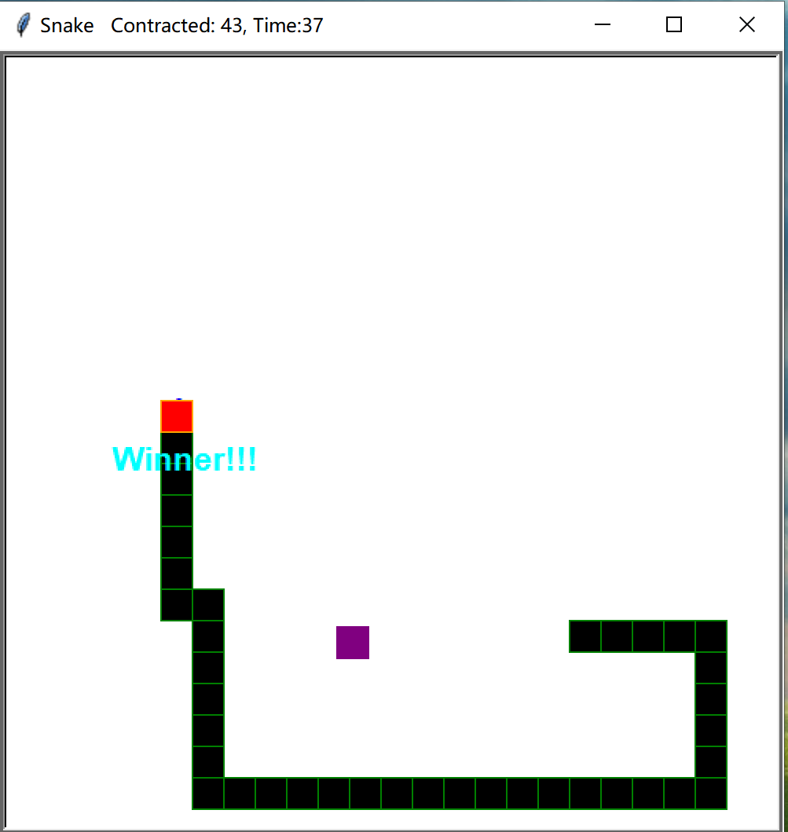
- Game Over
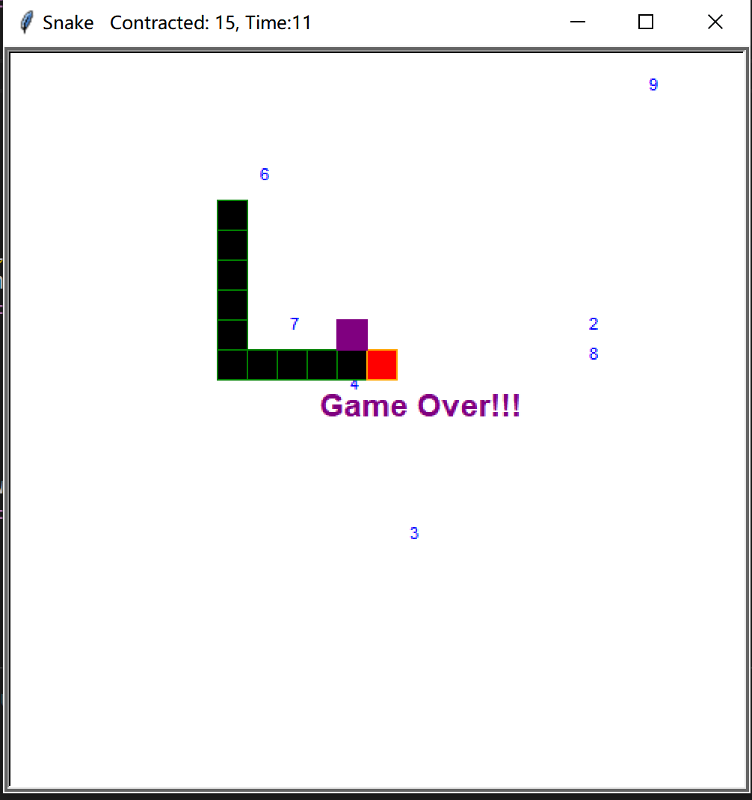
- Zero foods consumed
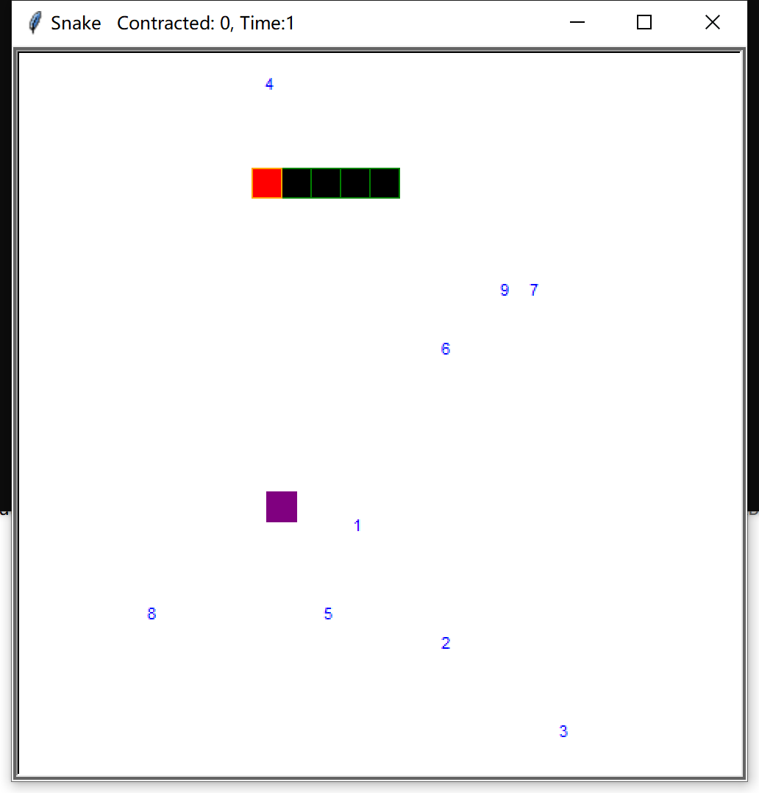
- Three foods consumed
